**General Information and Steps**

* **Procedure to create a system call:**

1. syscall.h:

**Info**: Each system call is mapped to a specific number. All of those declarations are listed in this file.

We need to assign a number to the new system call that we will create.

1. syscall.c:

**Info**: This file contains the **declaration** of all the system call wrapper functions currently available.

Then here, we need to **declare** a sys_function() (system function) which will be a wrapper function to the core function which we will be defined later. This function is extern meaning it becomes a global function.

Then this function is also added as an item to the array of system calls syscalls[] which is then later used by syscall() function to call the system calls.

1. sysproc.c:

**Info**: This file contains all the **definition** of all the system call wrapper functions **related to process**.

Then here, we need to **define** the body of the previously **declared** sys_function() (system function) which will be a wrapper function to the core function which we will define later.

Note: Many time the instead of wrapping the core function, we use the built in functions to perform the required operation and end the job here itself without needing to declare another core function and wrapping it here.

1. usys.S:

**Info**: This is an assembly file contains instructions of SYSCALL() function calling the defined system call functions.

Here we need to add SYSCALL(system_call_function_name)

1. user.h:

**Info**: This file contains all the declaration of all the system call core functions.

Here we need add the declaration of the core function that we previously wrapped inside a system call wrapper function. We will call only these functions later in our user level programs.

1. In sysproc.c, instead of using built-in functions to get the job done, if we have to define a core function in some other .c file (when the given built-in functions cannot provide the required functionality), in that case we define the system call core function in the required file.
2. defs.h:

**Info**: This file contains all the definition of all the system call core functions present in all of the core .c files of xv6.

Here we need add the declaration of the core function that we added in one or many of the core .c files of xv6.

* **Procedure to create a user level command:**

1. <filename.c>:

**Info**: This is the file that will contain the main() function which will become one of the command available in xv6. It can call system calls within it.

1. Makefile:

**Info**: This file contains information all the .c files that are required to be compiled before running xv6. If we make any changes any of the .c files, the make will read the Makefile and recompile only those files that that got changed and the files that depend on the changed files.

We need to add the filename of the .c file in the UPROGS section of the Makefile and add “filename.c” in the EXTRA section of the Makefile.

Now we can compile xv6 by typing make in the terminal & run it by typing make qemu-nox.

**Q1. Create a system call called getppid() and create a command called "mytest" where you need to display the process-id along with parent process-id. (use the help of getpid).**

**A:**

Following all the general instructions to create a system call, we will create system call when called will return the PID of the parent of the current process where this call is made.

The changes that were made:

1. syscall.h:

A a number was assigned to the new system call SYS_getppid. This was done by adding the following line to this file.

#define SYS_getppid   24

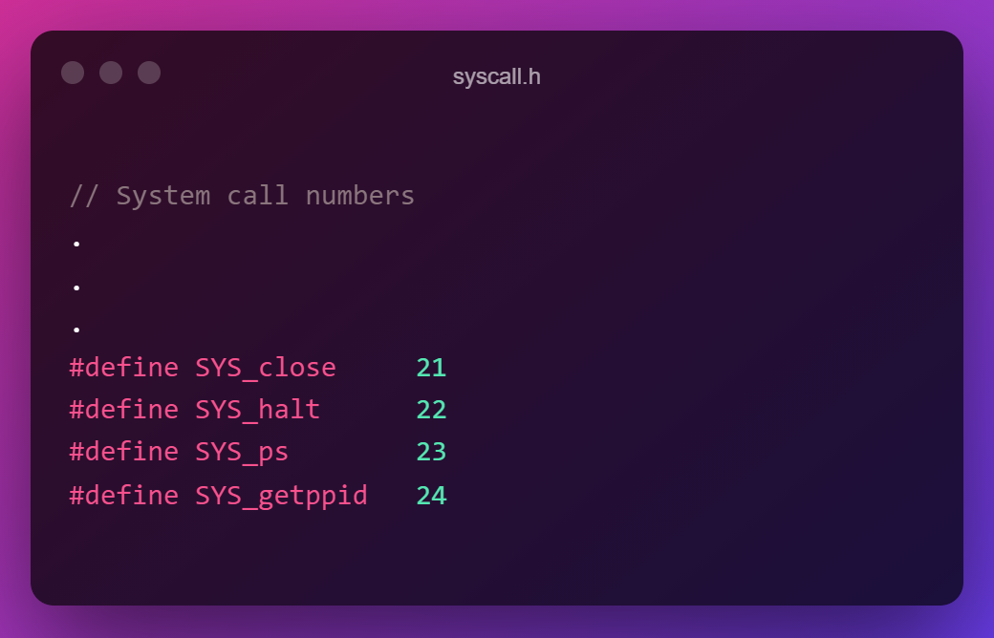

1. syscall.c:

A system function sys_getppid() was added to this file where all the other declarations were present. extern is put before to make the function globally available.

Then the name of the function sys_getppid is also added as an item to the array of system calls syscalls.

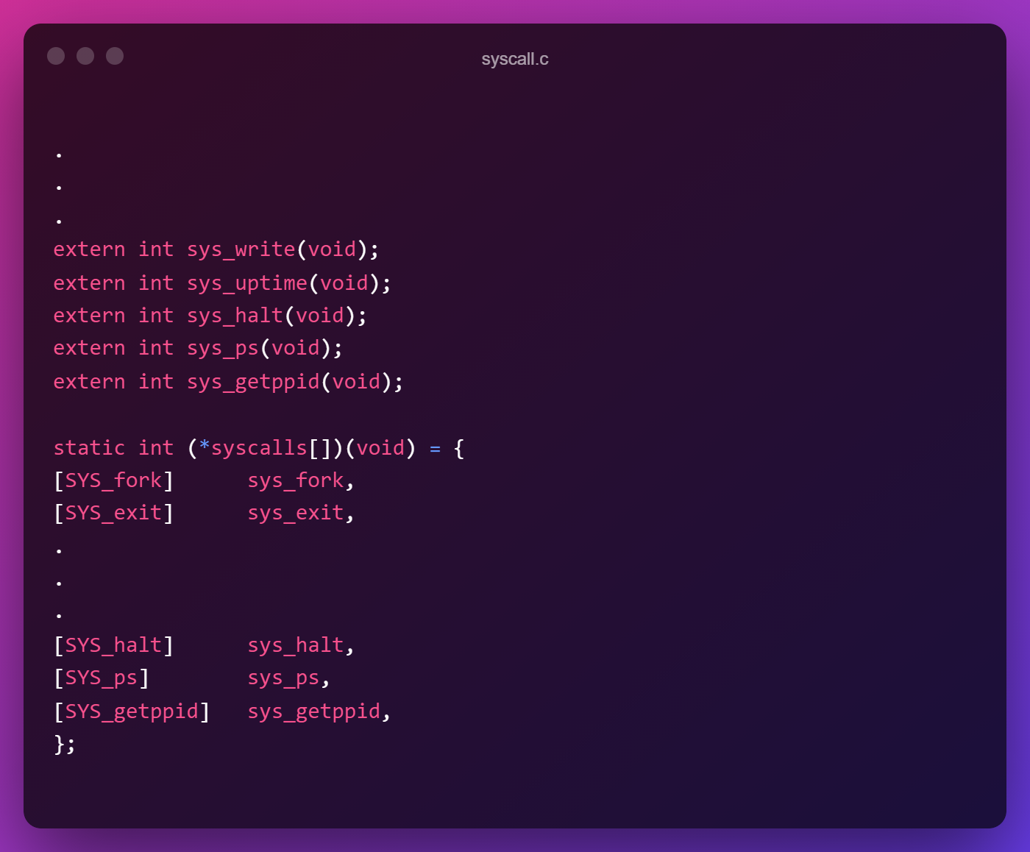

1. sysproc.c:

Here, the body of the previously **declared** sys_getppid() is **defined** as follows:

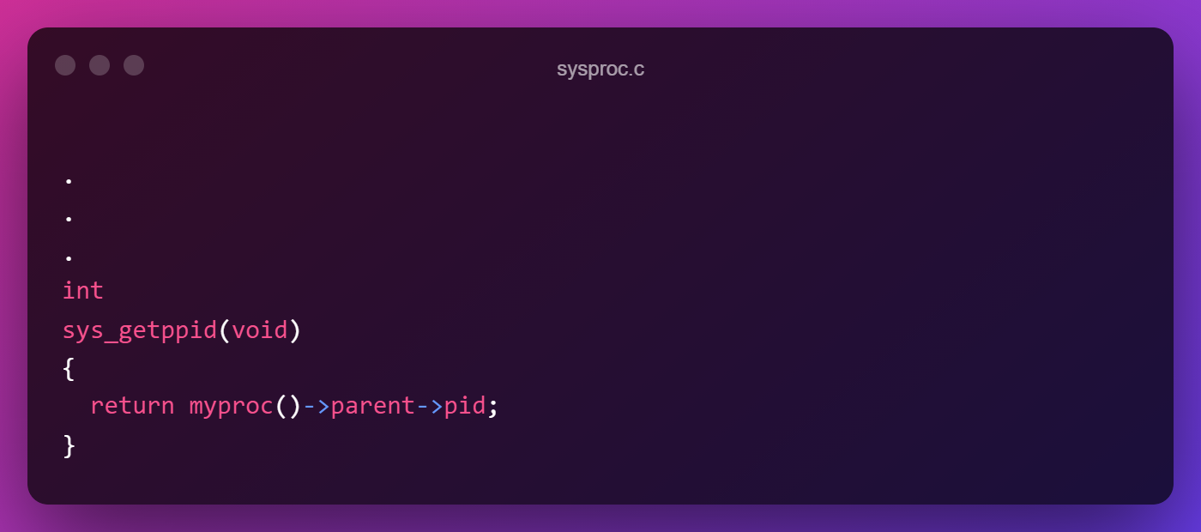

It calls a function myproc() which returns the struct proc * which is a pointer to the process structure with the process being the one who has called this function. From here we can access its member parent which is also a struct proc * which refers to the parent process structure from where we can get the PID.

1. usys.S:

Here we need to add SYSCALL(sys_getppid) in this file

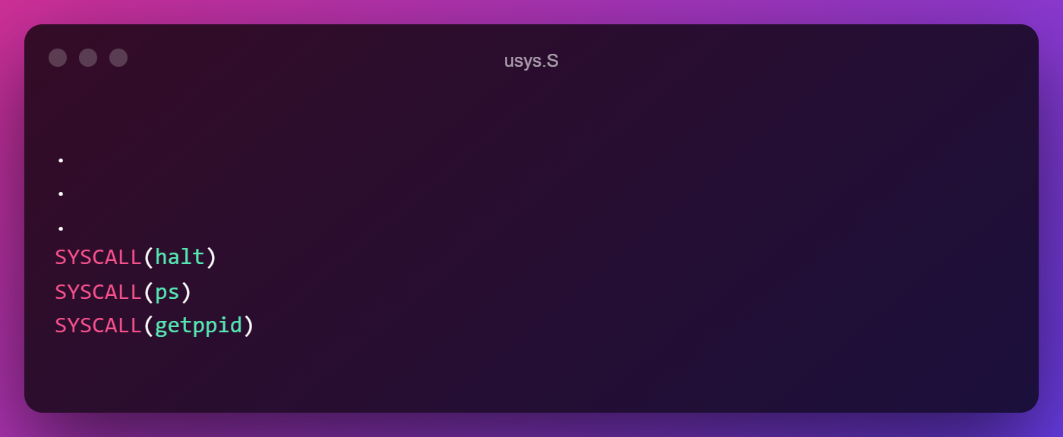

1. user.h:

Here we declare the core function for which we created a system call wrapper function inside sysproc.c.

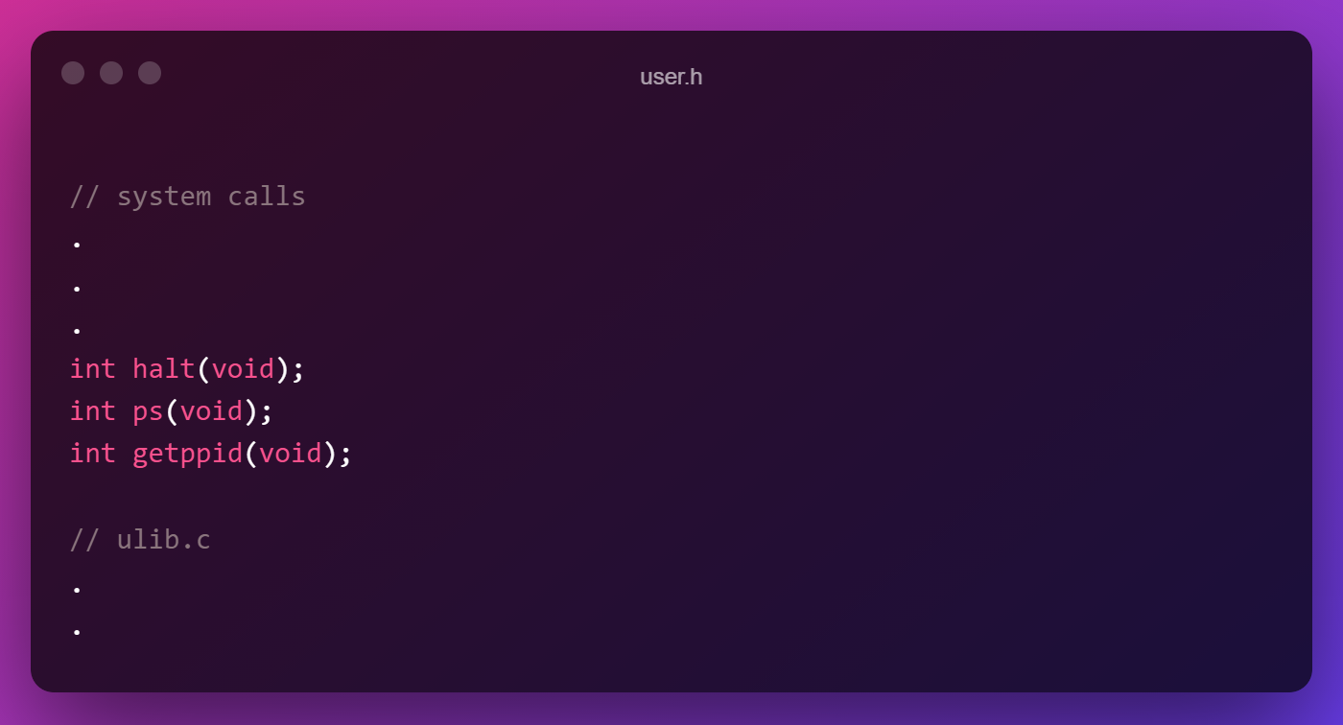

Now, following all the general instructions to create a user command, we will create user command which when called will create a process (parent) which then will generate 5 child process and in each of the process we will make the getppid() system call and display their process PID along with their parent PID.

1. getppidtest.c:

**Note**: Although in the question it asked the command name to be mytest, I am making it as getppidtest but will show the required demonstration of the asked system call.

This file contains the program that will be compiled and run in xv6:

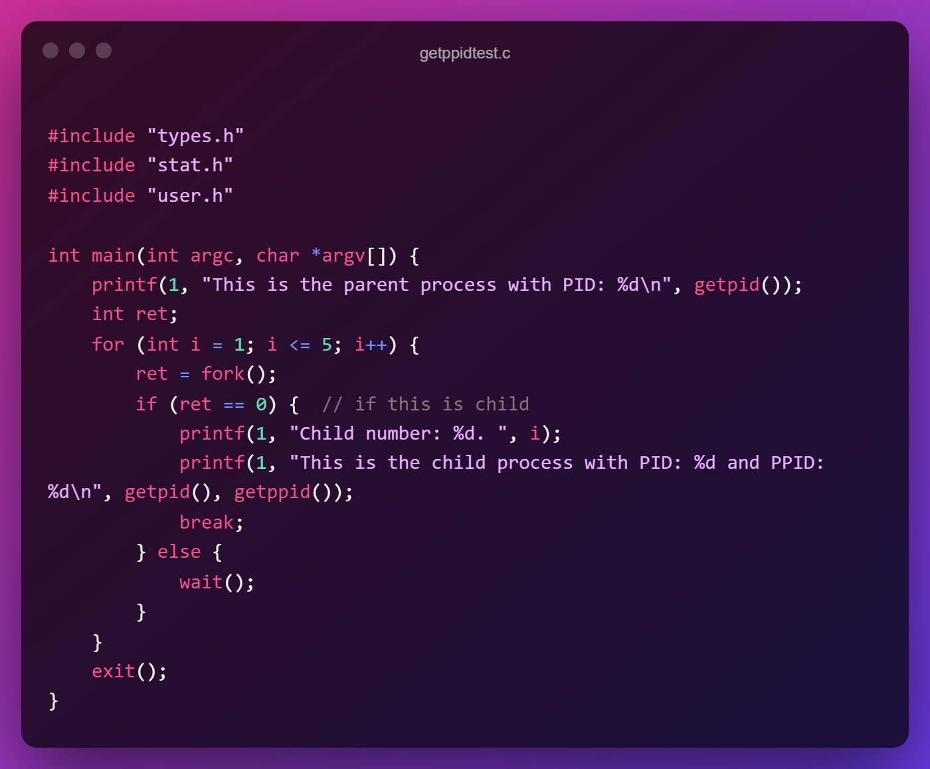

1. Makefile:

We need to add the filename i.e. getppidtest file in the UPROGS section of the Makefile and add “getppidtest.c” in the EXTRA section of the Makefile.

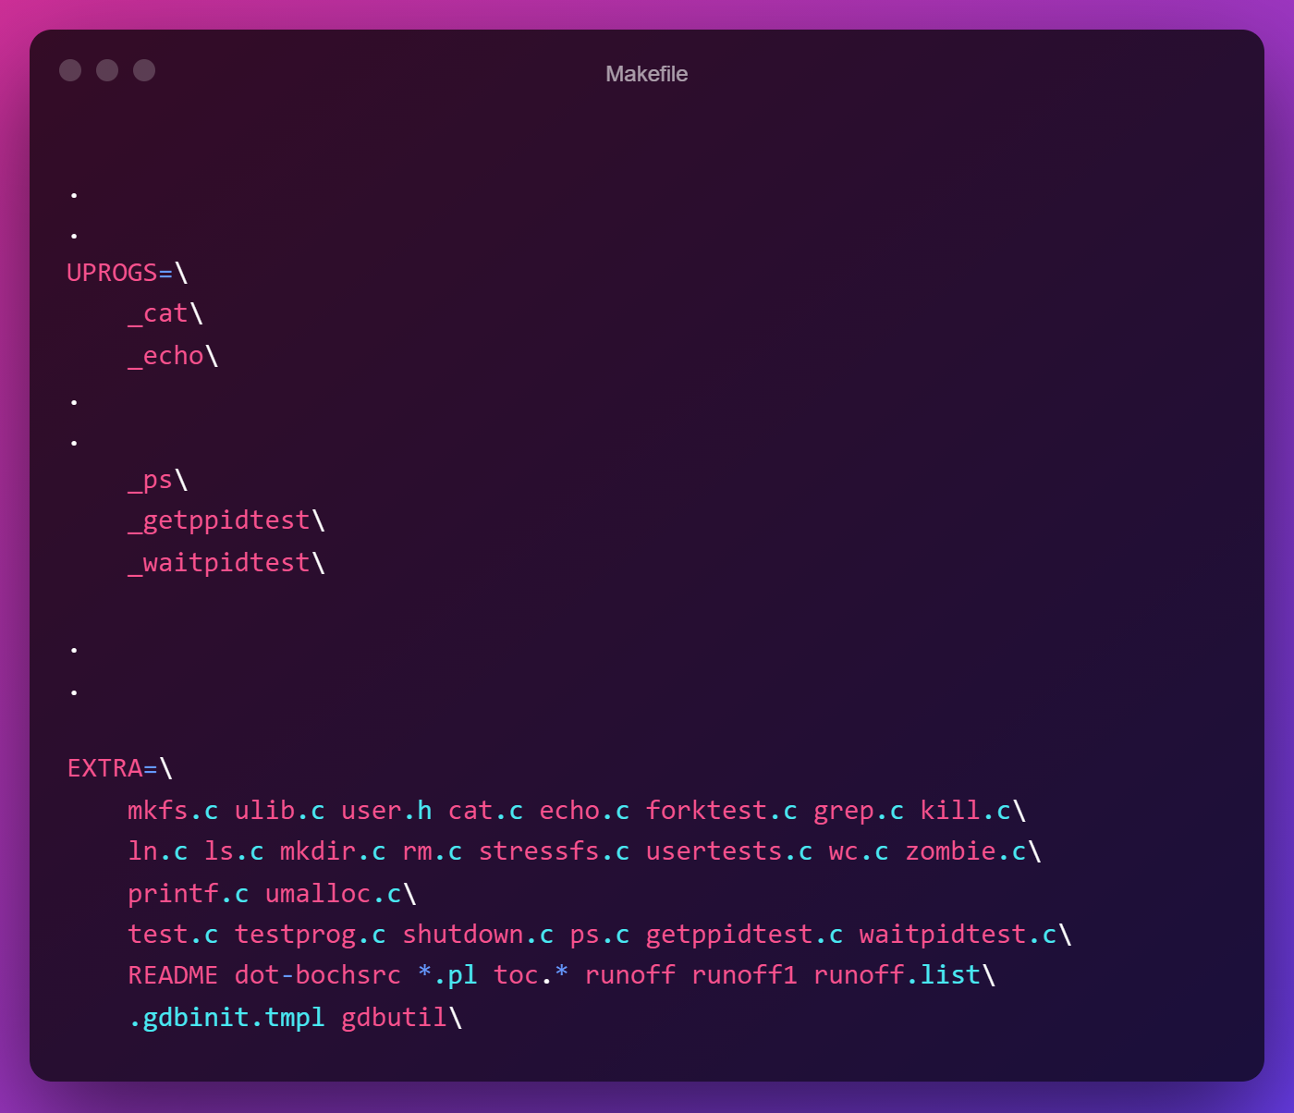

Now we can compile xv6 by typing make in the terminal & run it by typing make qemu-nox.

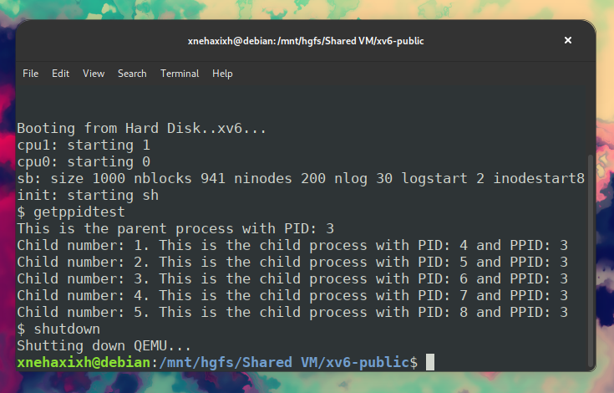

**Q2. Create a ps command that will display the following. You need to prepare a system call called sps(system processes) that will provide the following information.**

**PID, PPID, Process name, process state**

**then you try to display the following**

**Your roll no, PID, PPID, Process name, process state, process creation time, size of process memory.**

**A:**

Following all the general instructions to create a system call, we will create system call which will read all the process related information from the ptable array and print all the relevant information on the console in a proper format.

The changes that were made:

1. syscall.h:

A number was assigned to the new system call SYS_ps. This was done by adding the following line to this file.

#define SYS_ps   23



1. syscall.c:

A system function sys_ps() was added to this file where all the other declarations were present. extern is put before to make the function globally available.

Then the name of the function sys_ps is also added as an item to the array of system calls syscalls.



1. sysproc.c:

**Note**: Although in the question it asked the function name to be sps(), I am making it as ps to follow the same naming scheme as others are named but will show the required demonstration of the asked system call.

Here, the body of the previously **declared** sys_ps() is **defined** as follows:

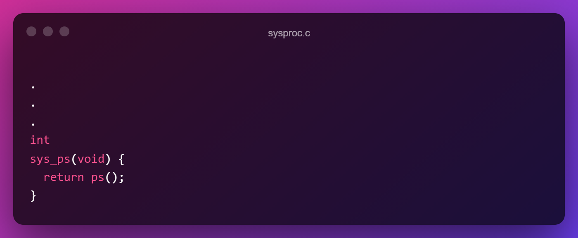We will create a wrapper system function wrapping the function ps() which we will define in proc.c, because we need to access the ptable array which contains the values and that is present in proc.c. That is the reason why we the core function is created in a different file and in sysproc.c we have created a wrapper function for it.

1. usys.S:

Here we need to add SYSCALL(ps) in this file

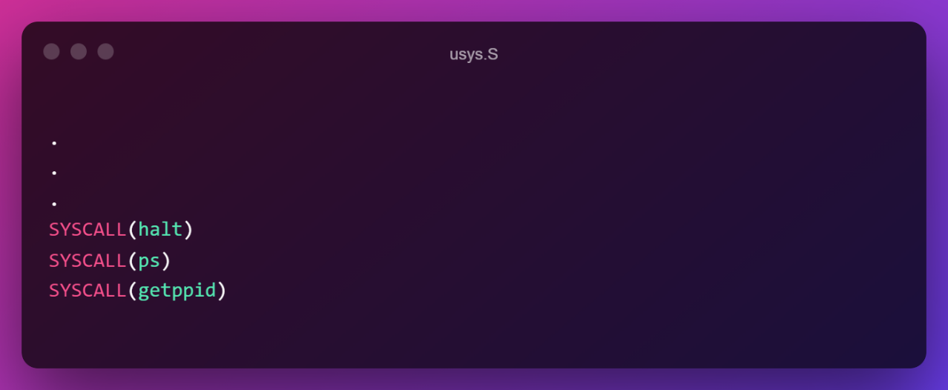

1. user.h:

Here we declare the core function for which we created a system call wrapper function inside sysproc.c.



1. proc.h:

In the proc structure, there is no attribute/member for creation time so we need to add that attribute/member by ourselves and implement something that will serve as a creation time.

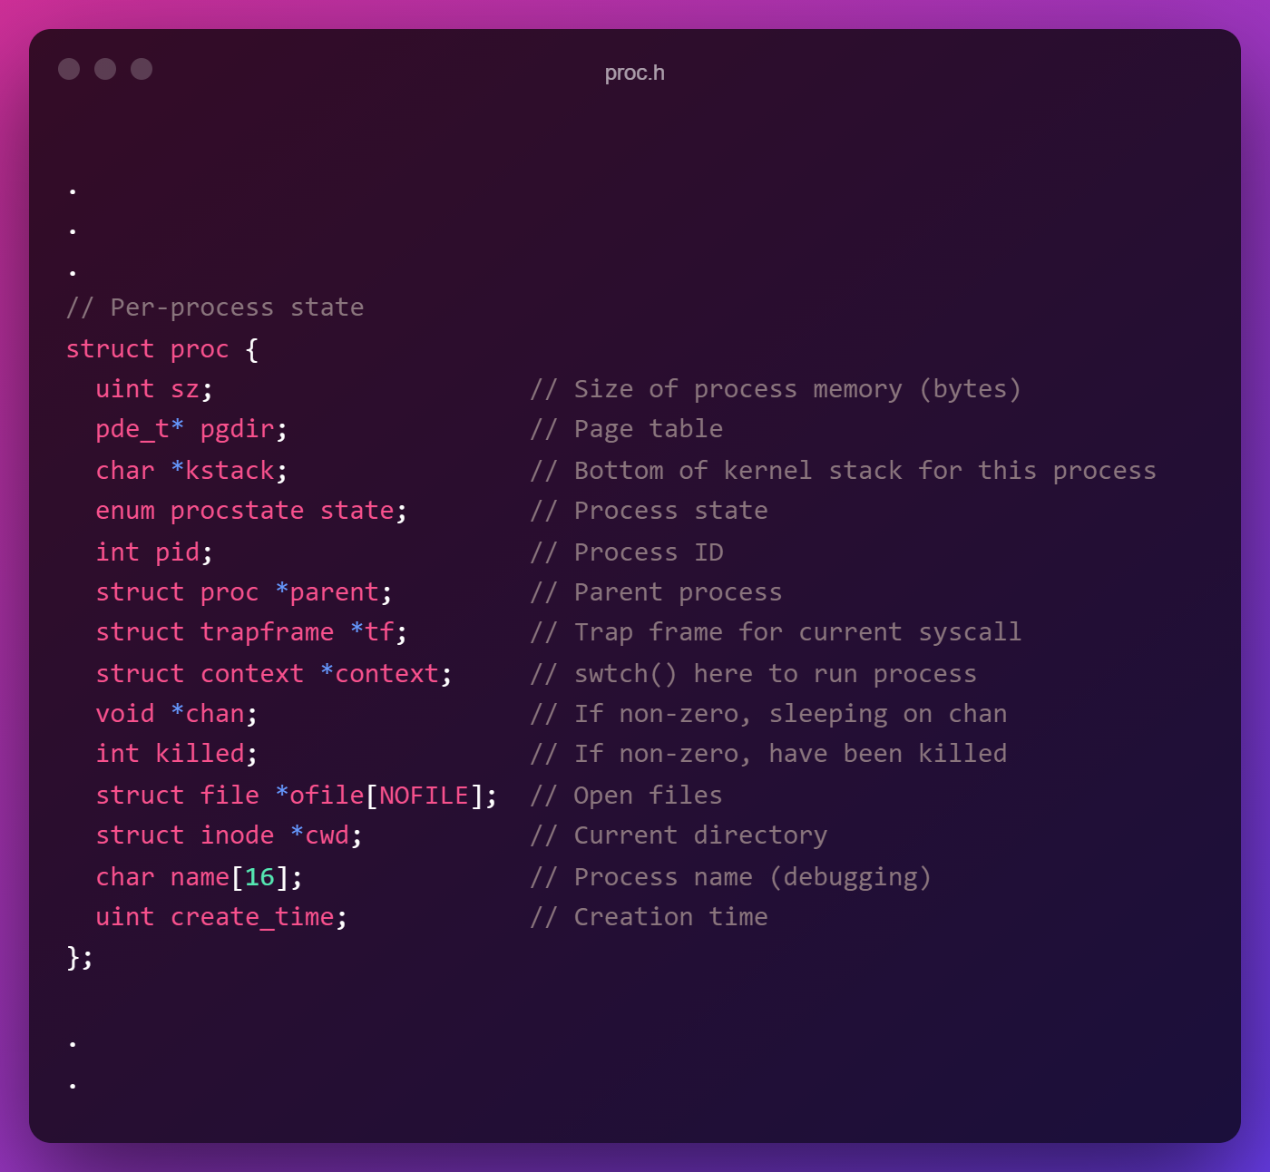

1. proc.c:

In the file we will implement the core function ps() that was previously wrapped in sysproc.c. Also we need to modify the allocproc() function which according to the documentation says:

“Look in the process table for an UNUSED proc. If found, change state to EMBRYO and initialize state required to run in the kernel. Otherwise return 0.”

So at the time of allocating the process, we will record the total ticks CPU has made and use it as the creation time.

So the modification to allocproc() will be by adding these lines:

   acquire(&tickslock);

  p->create_time = ticks;

  release(&tickslock);

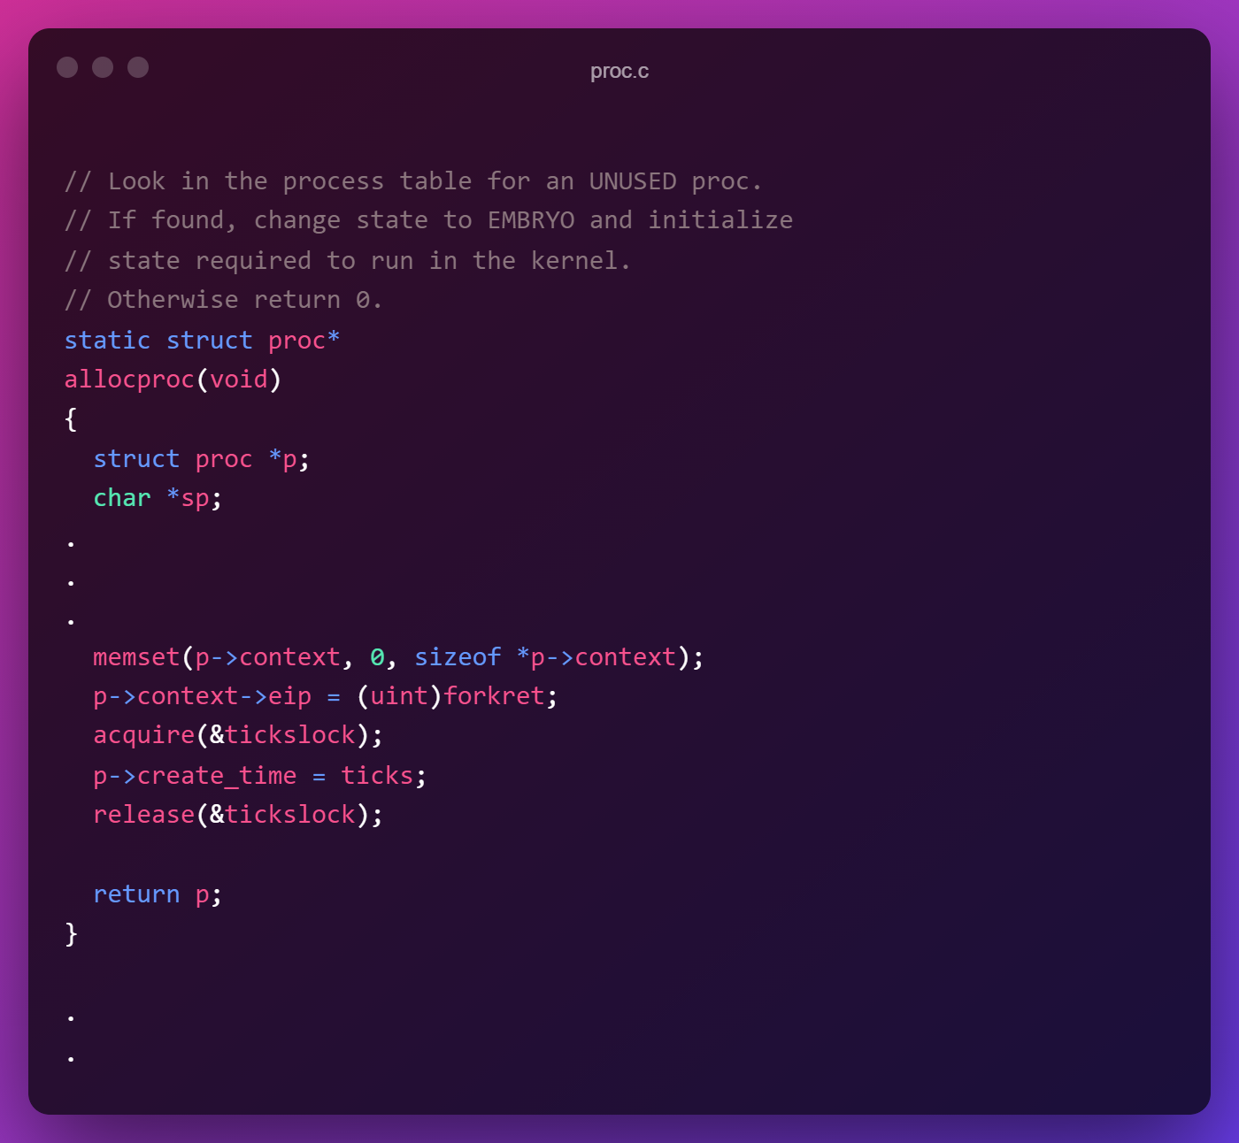

And we need to define the ps() function to get the required info from ptable and print them to console.

It will be defined as follows:

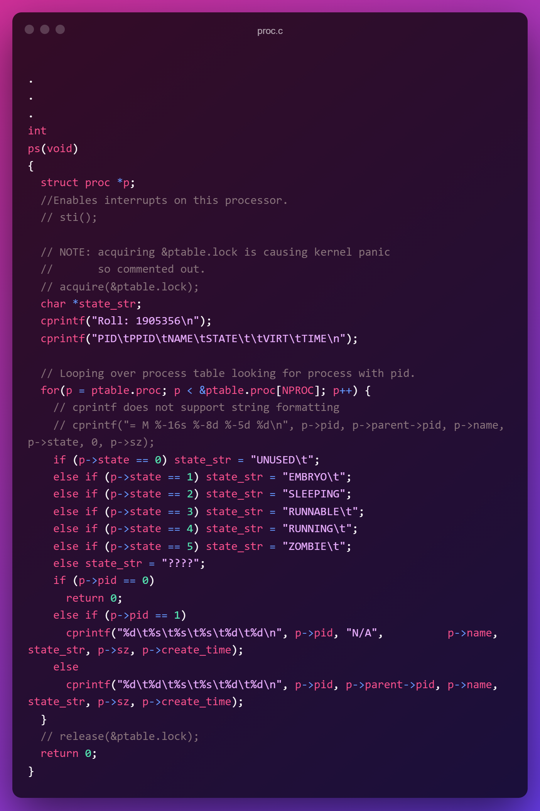

**NOTE:**

* Beside simple reading info from ptable and printing, there were some additional things that were done. Normal reading and printing list many processes with PID 0 which is invalid so when we encounter such a process, we return and end the function.
* Also, for process with PID 1, it has no parent so it has to be handled here by printing “N/A”.
* The acquiring of &ptable.lock was commented out because it was causing kernel panic after the ps command was executed.

1. defs.h:

As we have added a new function in proc.c, we have to specify it in this file at the corresponding section:

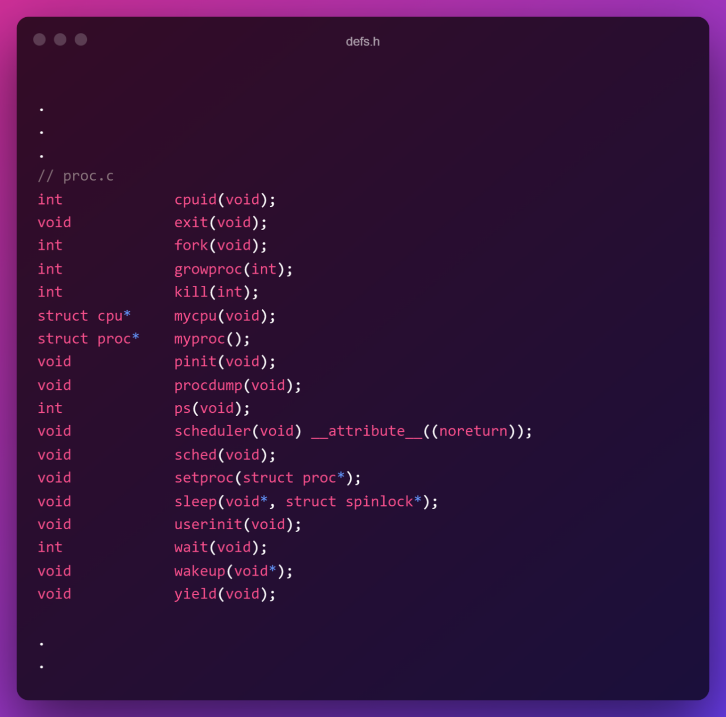

Now, following all the general instructions to create a user command, we will create user command which will call the system call ps() and display the required information.

1. ps.c:

This file contains the program that will be compiled and run in xv6:

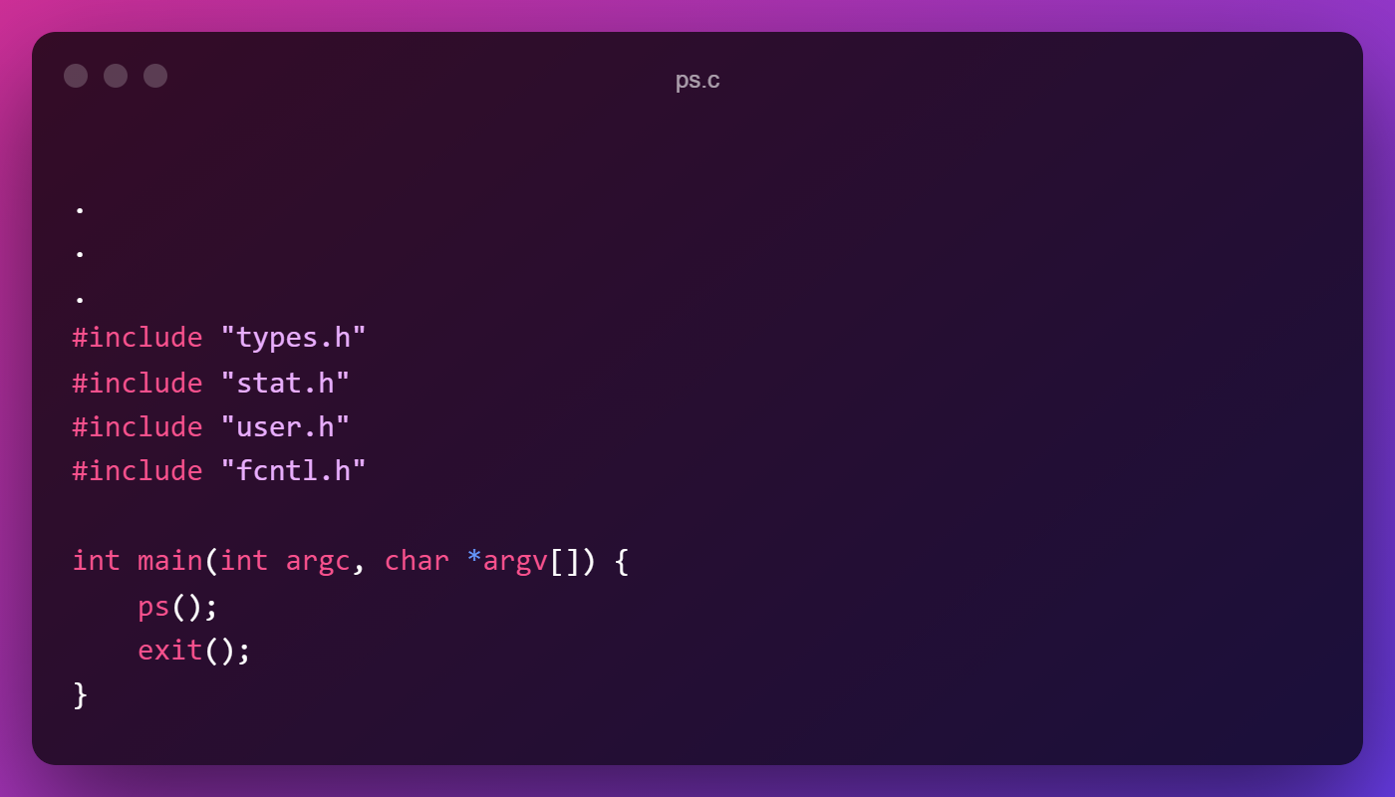

1. Makefile:

We need to add the filename i.e. ps file in the UPROGS section of the Makefile and add “ps.c” in the EXTRA section of the Makefile.

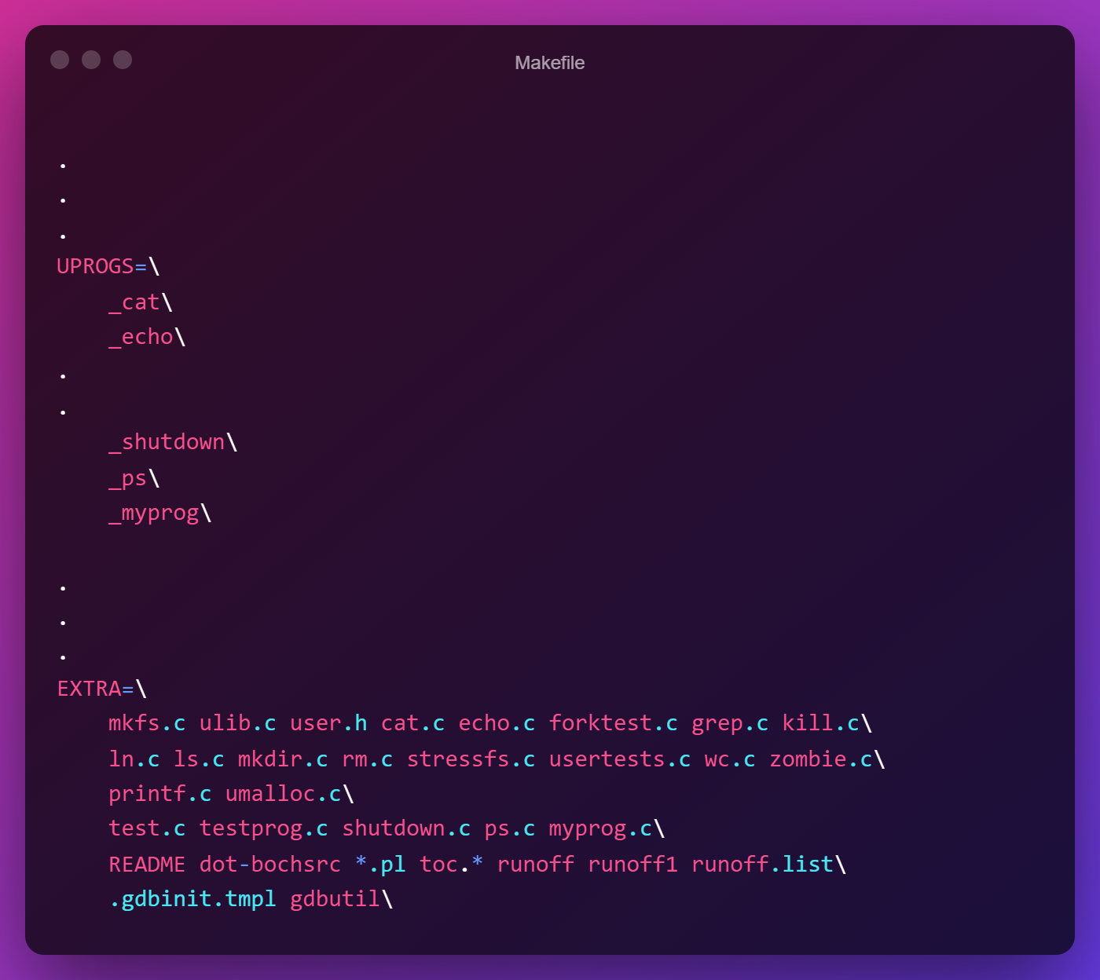

Now we can compile xv6 by typing make in the terminal & run it by typing make qemu-nox.

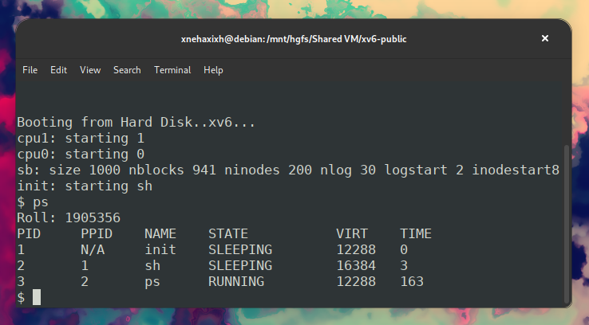

**Q3. Create a system call called “**waitpid(int pid)**” which will wait for specific child as passed as parameter to this system call. Write a program to test this system call. If one pass the PID as 0 then it will wait for all its child. This will return how many children processes a parent could wait plus your roll no.**

**A:**

Following all the general instructions to create a system call, we will create system call which will be almost similar to the wait() system call and make necessary changes as required.

The changes that were made:

1. syscall.h:

A number was assigned to the new system call SYS_waitpid. This was done by adding the following line to this file.

#define SYS_waitpid   25

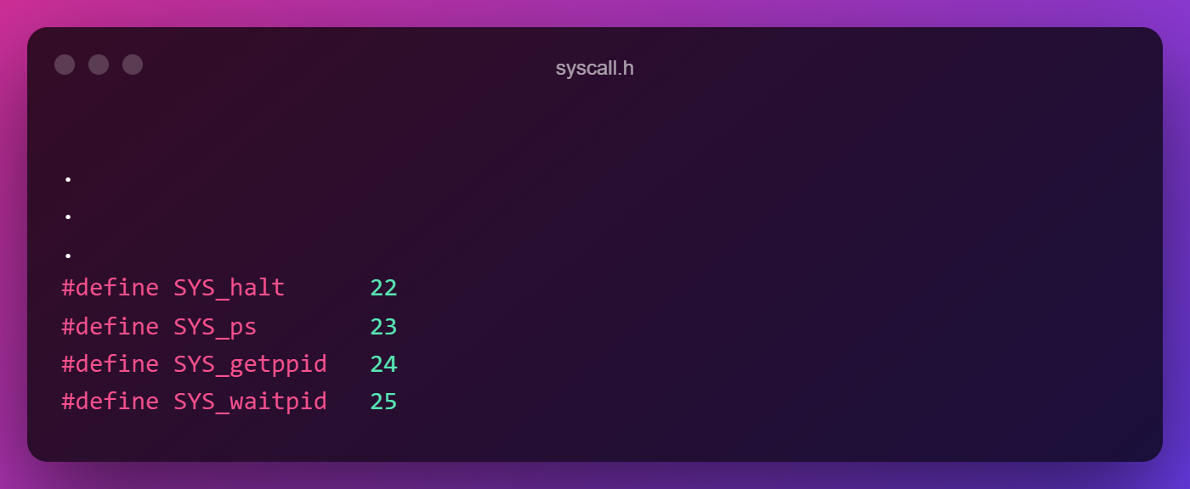

1. syscall.c:

A system function sys_waitpid(int) was added to this file where all the other declarations were present. extern is put before to make the function globally available.

Then the name of the function sys_waitpid is also added as an item to the array of system calls syscalls.

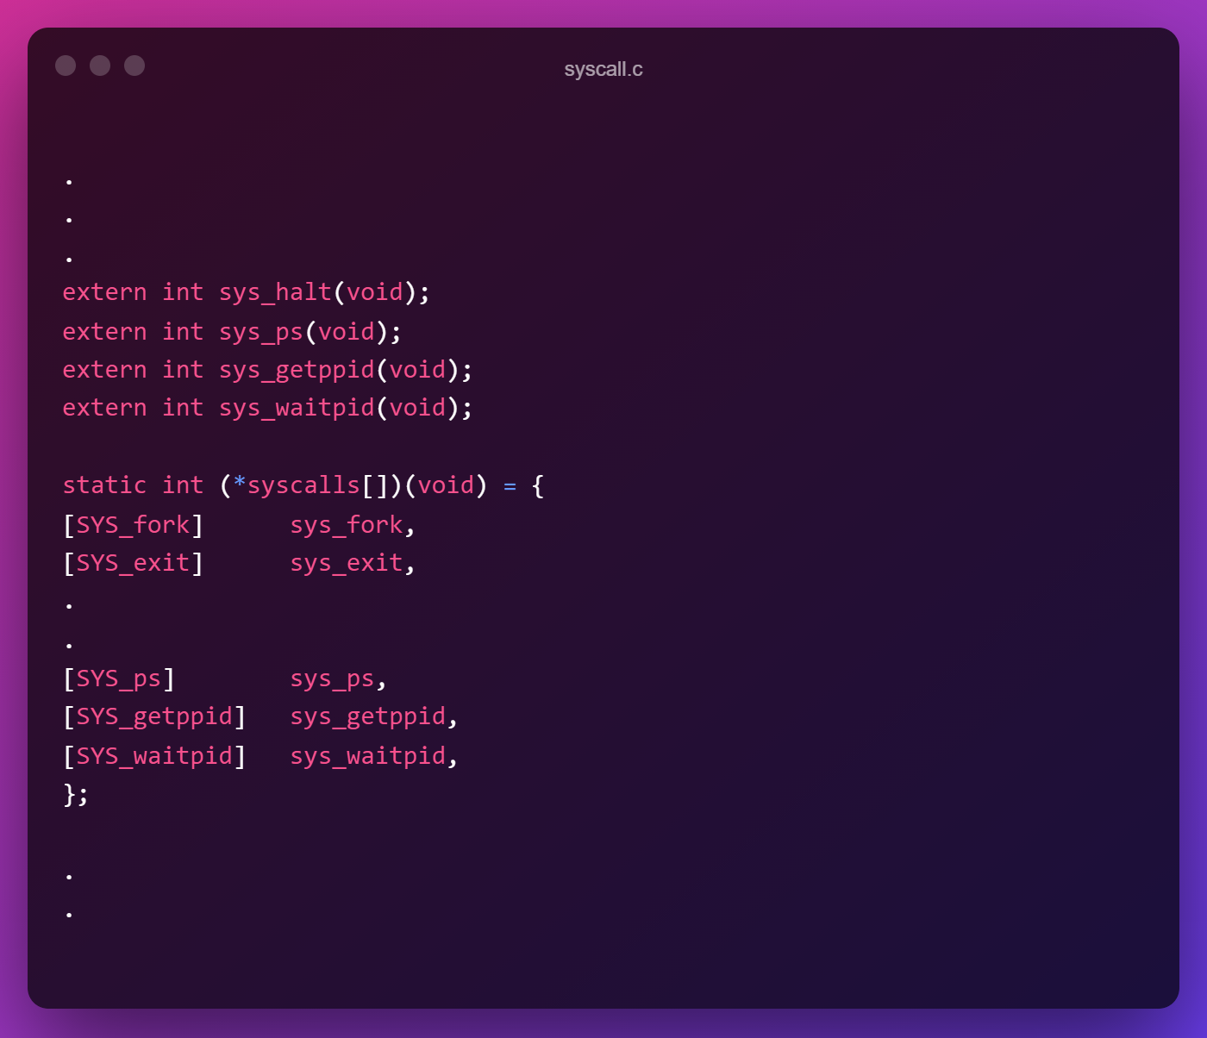

1. sysproc.c:

Here, the body of the previously **declared** sys_waitpid() is **defined** as follows:

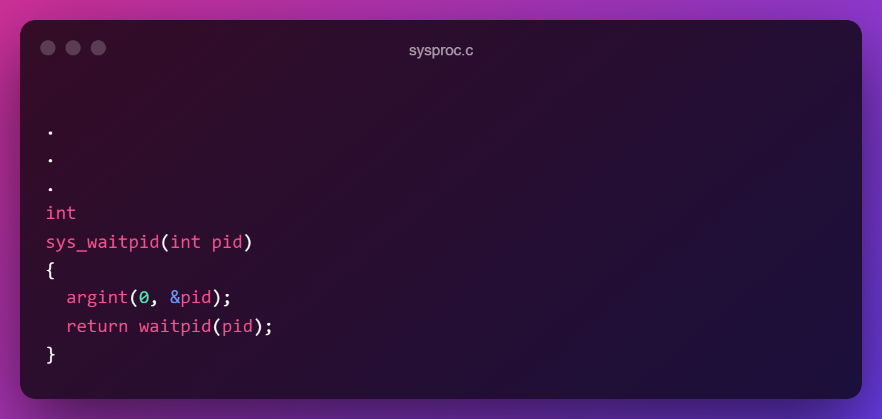

We have used the argint() function to retrieve arguments from the user command so that we can pass it to the core function i.e. waitpid(). argint() takes 1st parameter specifying the argument number and 2nd parameter address of an integer variable where the original argument will be written. This is how we pass an argument from user command to core function.

So we declare a variable pid and receive the original argument from user command with the help of argint() and then pass pid to waitpid().

We will create a wrapper system function wrapping the function waitpid() which we will define in proc.c, because we need to access the ptable array which contains the values and that is present in proc.c. That is the reason why we the core function is created in a different file and in sysproc.c we have created a wrapper function for it.

1. usys.S:

Here we need to add SYSCALL(waitpid) in this file

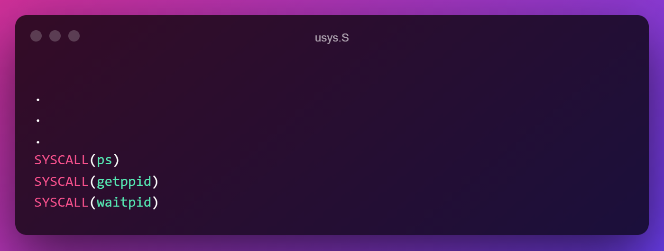

1. user.h:

Here we declare the core function for which we created a system call wrapper function inside sysproc.c.

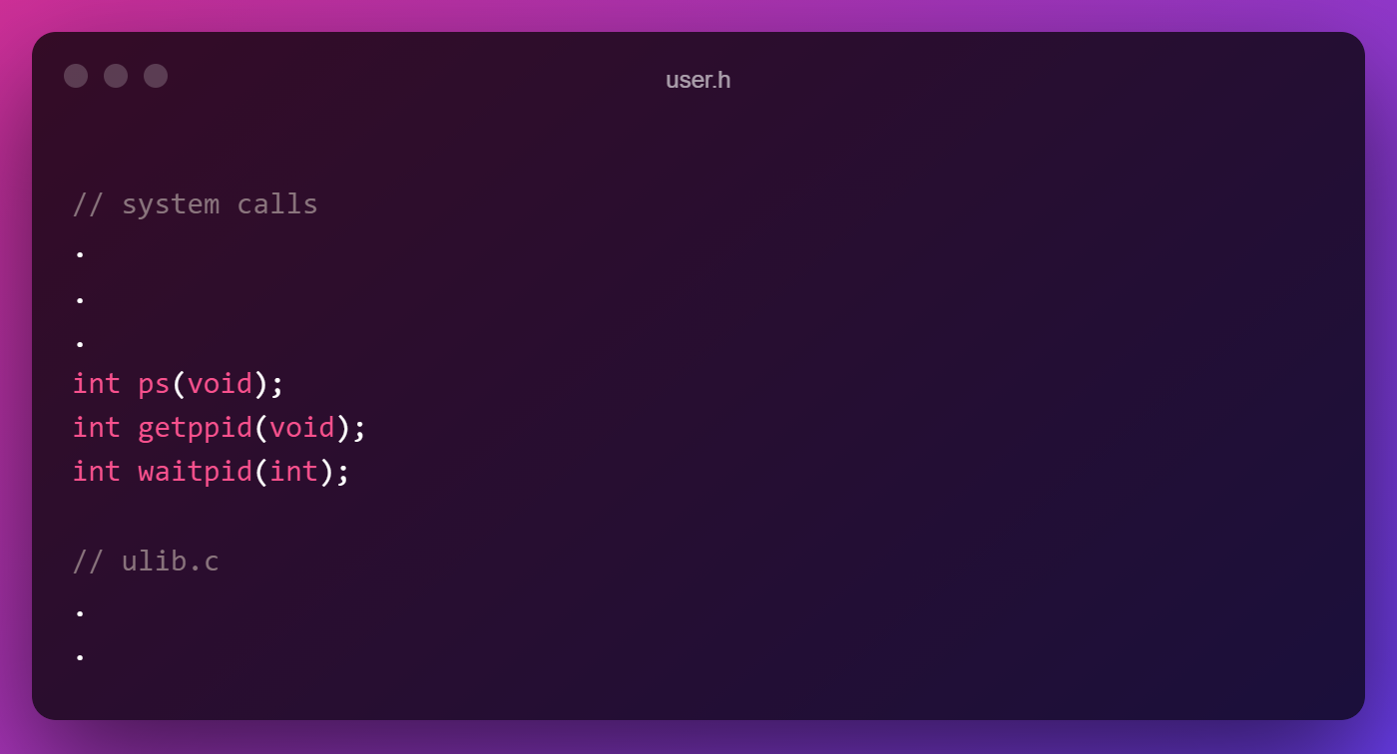

1. proc.c:

In the file we will implement the core function waitpid() that was previously wrapped in sysproc.c which will be similar to the wait() function with slight modifications.

It will be defined as follows:

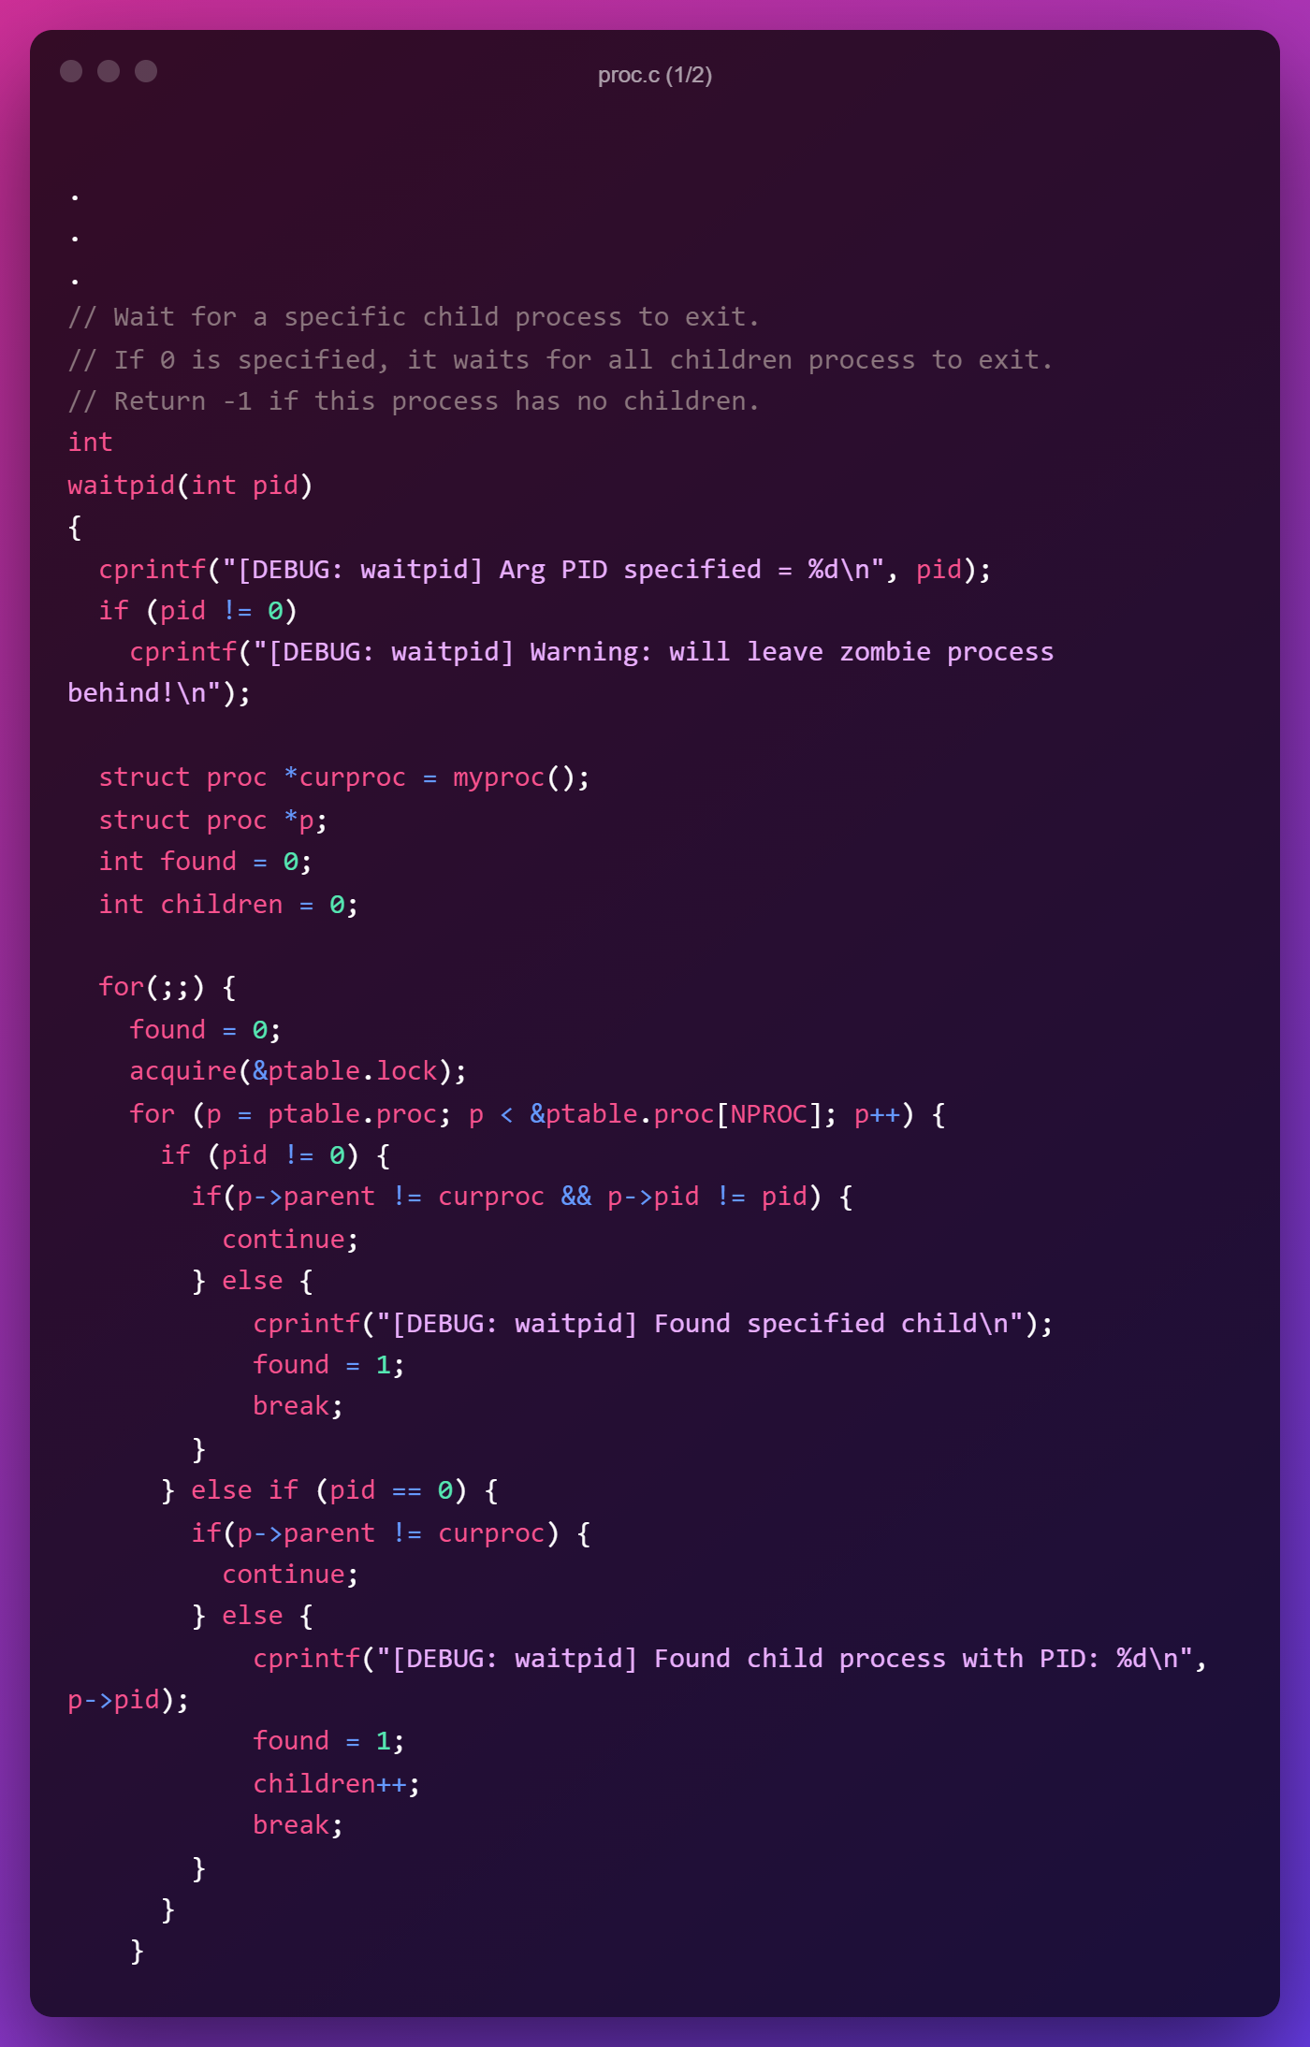

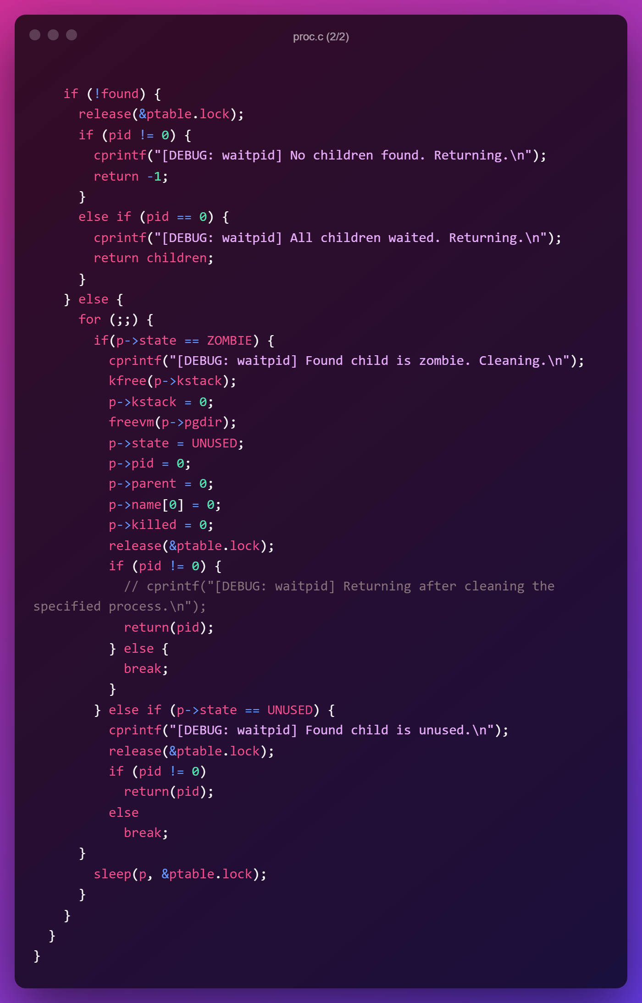

**Note**: if upon executing the final command something like “panic” prints on the terminal that means a kernel panic has occurred.   
A kernel panic is a safety measure taken by an operating system's kernel upon detecting an internal fatal error in which either it is unable to safely recover or continuing to run the system would have a higher risk of major data loss.  
Here, a kernel panic can occur if the locks are not handled properly. So, it has to be made sure that if a lock is acquired then it must be released before the control goes outside the scope of this function to some other function which again handles locking separately.

The implementation is similar to wait(). It involves iterating through the ptable and checking for a specific PID child process, if it is found, it is waited for and then the function returns. If the argument specified is 0 then we keep iterating through the ptable and for each child found we wait and keep doing this cycle till there are no more child process found in the ptable.

1. defs.h:

As we have added a new function in proc.c, we have to specify it in this file at the corresponding section:

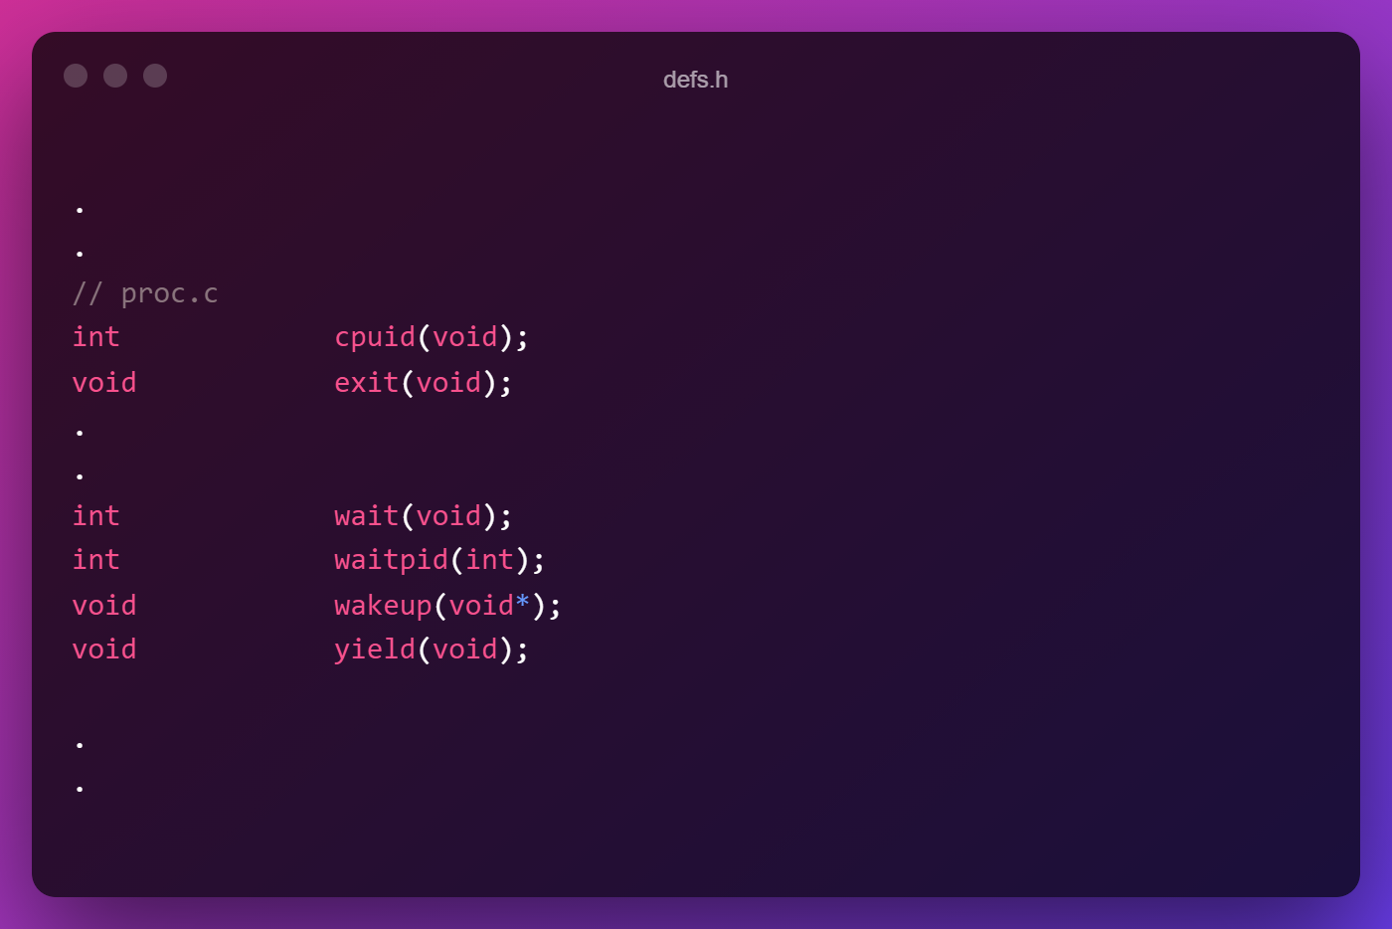

Now, following all the general instructions to create a user command, we will create user command which will call the system call waitpid() and display the required information.

1. waitpidtest.c:

This file contains the program that will be compiled and run in xv6:

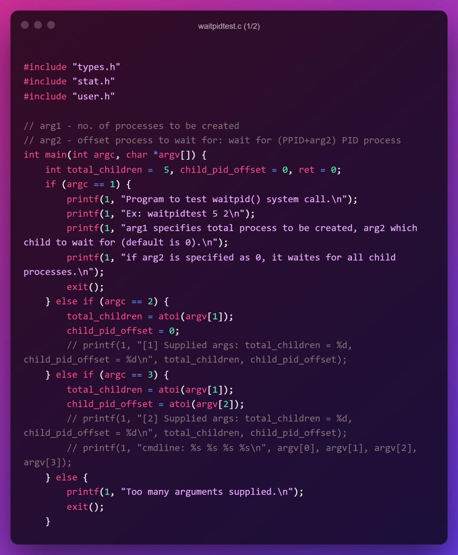

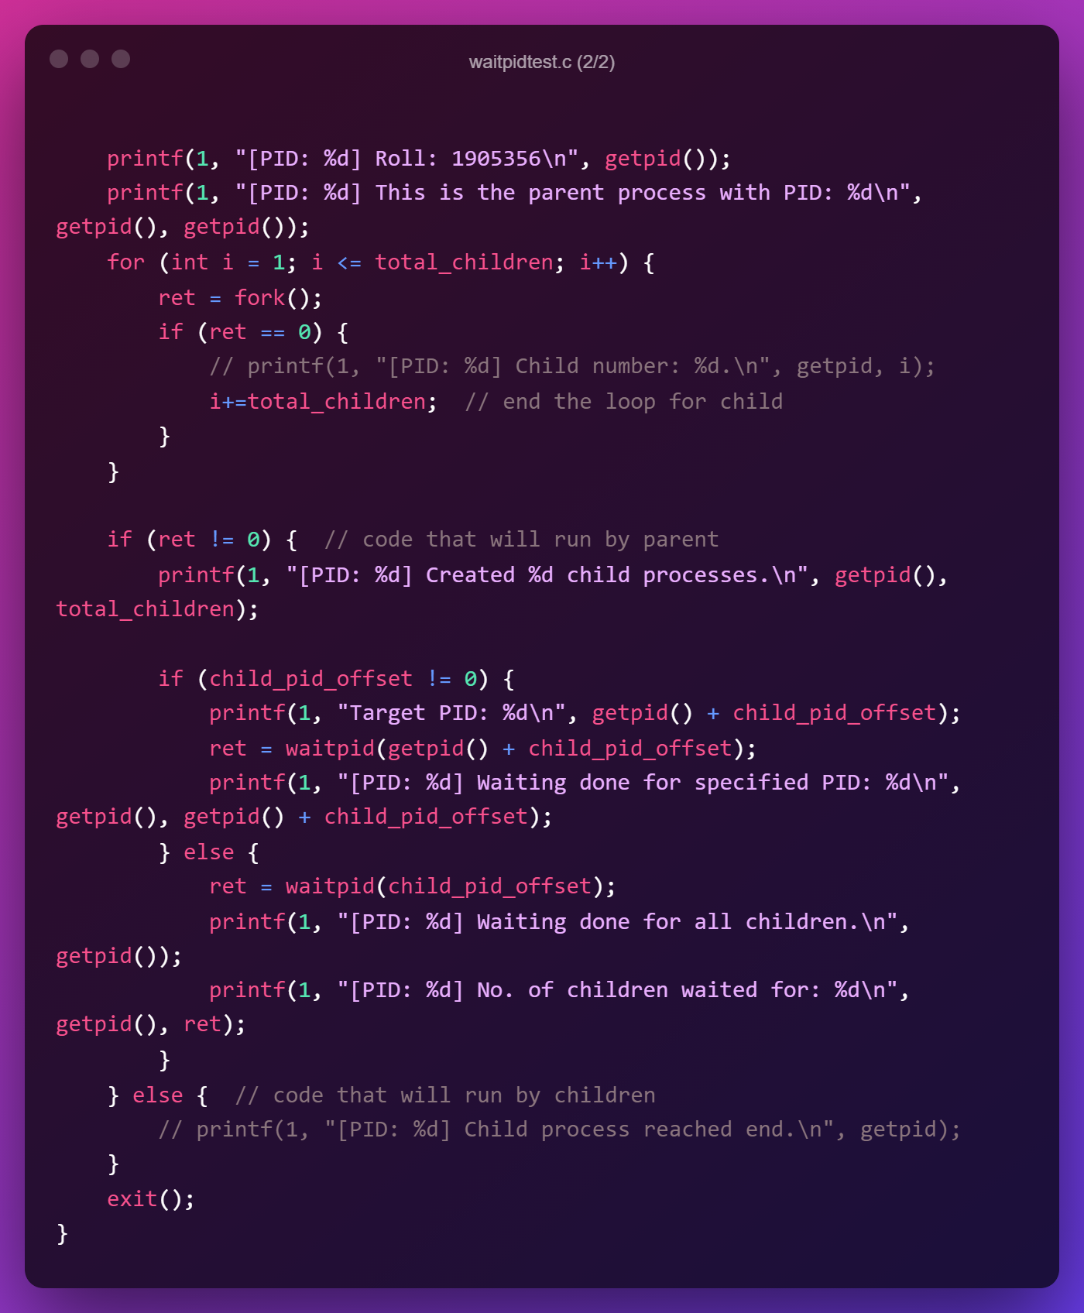

**Note**: The question had asked that the user will specify the PID but here to demonstrate waiting for a specific PID the user will specify an offset PID which will be added to the parent PID and that will be our final PID for which we will wait. This is because when the process is created the user won’t know what is the exact PID of the child process so this offset method is implemented just for the sake of demonstration.

This program accepts 2 parameters, 1st is how many child process will be created, 2nd is which PID offset to wait for (which basically becomes which number child to wait for). If its 0 then the parent will wait for all of its child.

1. Makefile:

We need to add the filename i.e. waitpidtest file in the UPROGS section of the Makefile and add “waitpidtest.c” in the EXTRA section of the Makefile.

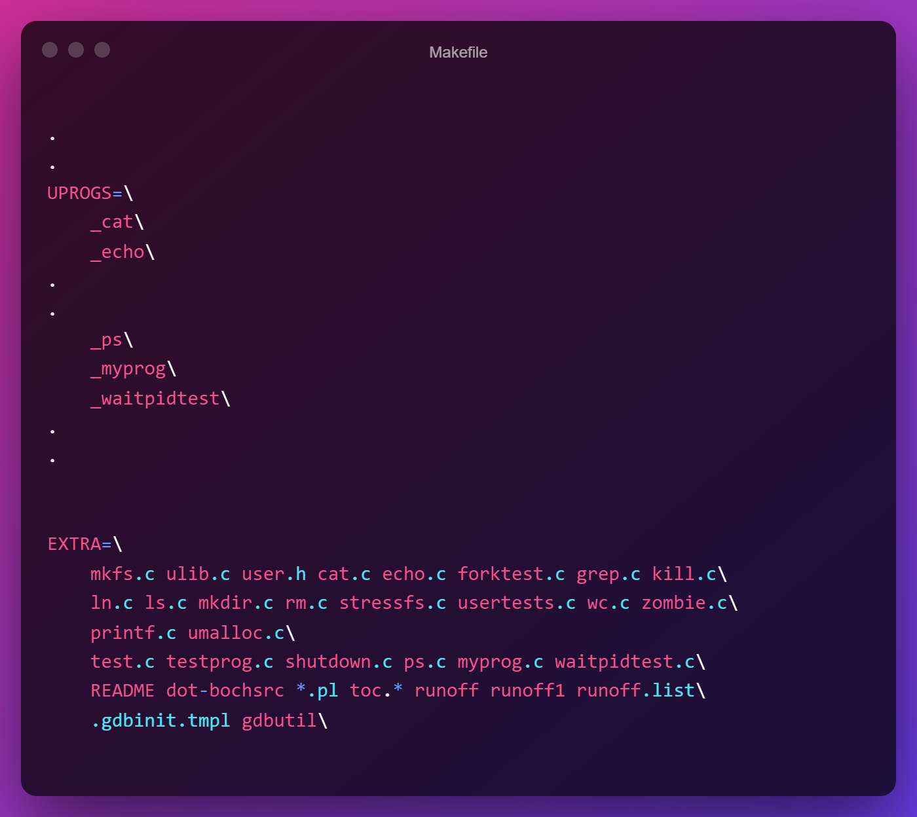

Now we can compile xv6 by typing make in the terminal & run it by typing make qemu-nox.

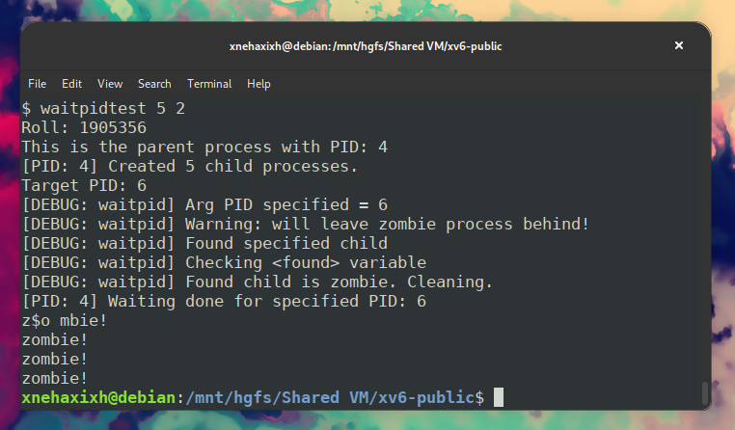

**Note**: Here 5 children processes were created with parent PID being 4 and we waited for PID (4 + 2 =) 6 which is the 2nd child. The console prints “zombie!” indicating the other children process finished but the parent didn’t wait which fulfills the demonstration of waiting for a specific PID.

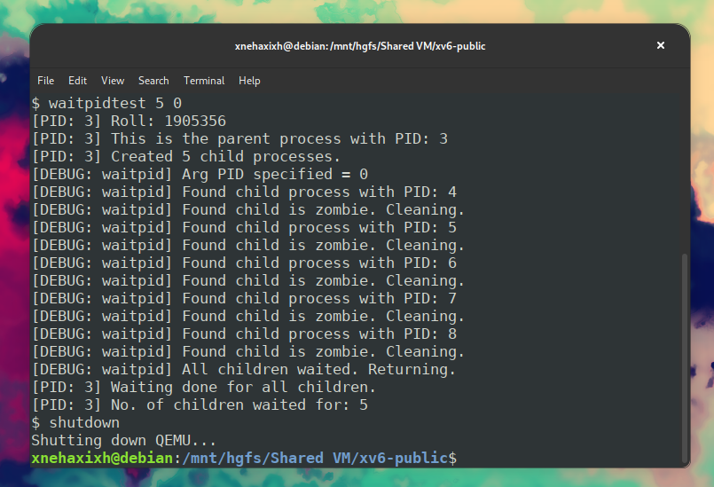

**Note**: Here 5 children processes were created with parent PID being 3 and the 2nd argument was given 0 meaning we will have to wait for all processes. The waitpid() was designed to show verbose output of its action so the prints when it has waited for a process. The above output states that it waited for all of the processes which fulfills the demonstration.

**∎**